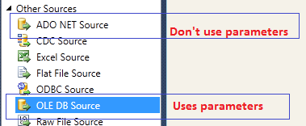

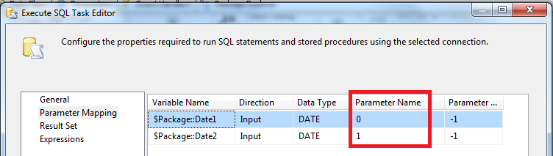

**DECLARE @DATE1 DATETIME**

**DECLARE @DATE2 DATETIME**

**SELECT @DATE1 = ?**

**SELECT @DATE2 = ?**

BEGIN TRAN

DELETE FROM EventActionHistory

WHERE DateCreated >= **@DATE1**

AND DateCreated <= **@DATE2**

COMMIT TRAN

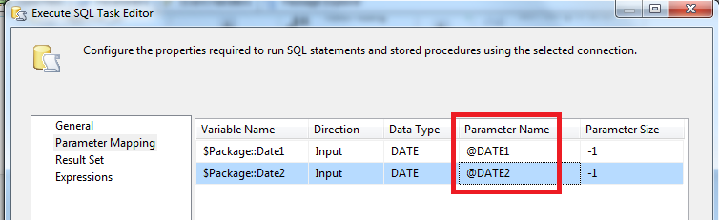

BEGIN TRAN

DELETE FROM EventActionHistory

WHERE DateCreated >= **@DATE1**

AND DateCreated <= **@DATE2**

COMMIT TRAN